2019 AP Macro Exam

Multiple Choice Section

- An economy is operating at a point inside its production possibilities curve ( PPC ). Which of the following will most likely cause the economy to move toward the current PPC in the short run?
- A decrease in government spending
- A decrease in inflation
- An increase in human capital
- An increase in employment
- An increase in imports
- An increase in which of the following will most likely promote economic growth?
- Taxes on investment
- The price level
- Human capital
- Consumption of nondurable goods
- Interest rates
- Which of the following will cause aggregate supply to increase in Country X?
- An increase in personal income taxes
- The discovery of low-cost alternative sources of energy
- A decrease in labor productivity with no change in nominal wages
- Depreciation of country X’s currency on the foreign exchange market
- An increase in the price level
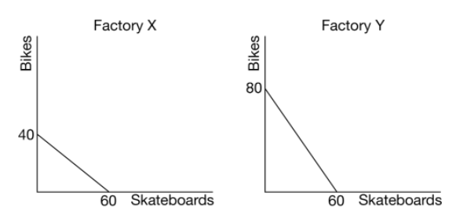
- The graph above shows the production possibilities curve for Factory X and Factory Y. If Factory X uses the same amount of resources to produce skateboards and bikes as Factory Y uses, which of the following is true?
- Factory X has an absolute advantage in producing bikes.
- Factory X has an absolute advantage in producing skateboards.
- Factory X has a comparative advantage in producing skateboards.
- Factory Y has a comparative advantage in producing skateboards.
- Factory Y has an absolute advantage in producing skateboards.
- An increase in the price of oil, an important input to production, will result in which of the following in the short run?
- A decrease in the price level
- A decrease in short-run aggregate supply
- A decrease in unemployment
- An increase in real wages
- An increase in aggregate demand
- An economy is currently operating at the full-employment level of output. Which of the following would result in a recessionary gap in the short run?
- An increase in the costs of production
- An improvement in the productivity of labor
- An increase in money supply
- A positive supply shock
- A decrease in income tax rates
- Thailand and Malaysia are trading partners. If the price level in Thailand decreases relative to the price level in Malaysia, what will happen to Thailand’s exports to Malaysia and Thailand’s aggregate demand?
Thailand’s Exports Thailand’s AD
- Increase Decrease
- Increase Increase
- Increase Indeterminate
- Decrease Decrease
- Decrease Increase
- Country X produces only apples and bananas. The following table shows prices and quantities of both products in two years.
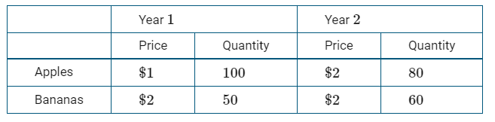
Assuming year 1 is the base year, what is the nominal and real gross domestic product (GDP) for year 2 ?
Nominal GDP Real GDP
- $200 $280
- $200 $200
- $280 $200
- $280 $560
- $560 $280
- Which of the following is a fiscal policy action aimed at reducing unemployment?
- Decreasing government expenditures
- Decreasing income taxes
- Decreasing tax credits
- Increasing nominal interest rates
- Increasing required reserves
- increases in human capital can be achieved by which of the following?
- Building more factories
- Reducing immigration of skilled workers
- Improving the quality of job-training programs
- Increasing the physical capital per worker
- Increasing government spending on infrastructure
- If the marginal propensity to save is 0.25 , a $15 billion increase in government spending will lead to an increase in national income by a maximum of
- $60 billion
- $45 billion
- $15 billion
- $11.25 billion
- $3.75 billion
- Assume the economy is currently in long-run equilibrium. An increase in the money supply will affect unemployment in the short run and in the long run in which of the following ways?
Short Run Long Run
- Falls Falls
- Rises Rises
- No change Remains at the natural rate
- Rises above the natural rate Falls back to the natural rate
- Falls below the natural rate Rises back to the natural rate
- The term “value added” for a firm is best defined as which of the following?
- The firm’s sales
- The firm’s sales minus depreciation
- The firm’s sales minus its losses
- The firm’s sales minus the cost of inputs purchased from other firms
- The firm’s profits from its sales
- An increase in a country’s current account surplus will result in which of the following in the short run?
- A decrease in the country’s government budget surplus
- A decrease in the country’s national savings
- A decrease in the country’s financial account deficit
- An increase in the country’s net financial capital outflows
- An increase in the country’s national debt
- Using 2010 as the base year, the gross domestic product (GDP) deflator in 2011 was 97. Which of the following must be true?
- The inflation rate in 2011 was positive.
- The inflation rate in 2011 was negative.
- The inflation rate in 2011 was zero.
- The purchasing power of a dollar decreased by 3 percent.
- The real output increased by 3 percent.
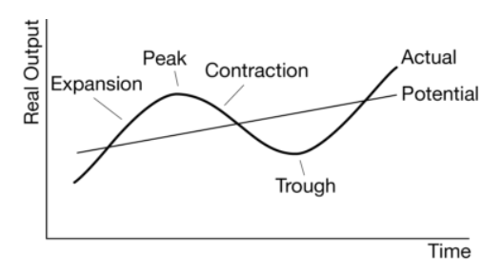
- ccording to the business cycle represented in the diagram above, the actual rate of unemployment equals the natural rate of unemployment when the economy is
- in expansion
- in contraction
- at the peak
- at the trough
- on the potential line
- A fiscal policy action to reduce inflationary pressure would be to increase which of the following?
- The required reserve ratio
- The discount rate
- Transfer payments
- Government spending
- Income tax rates
- The nominal gross domestic product of China in 2010 is a measure of the total value of which of the following in 2010 ?
- Financial assets, including stocks, in China
- Firms located within the borders of China
- Final goods and services consumed in China
- Final goods and services produced within the borders of China
- Final goods and services exported by China to the rest of the world
- Assume the government reduces its spending and raises income taxes in an effort to reduce the budget deficit. The most likely short-run result will be an increase in
- interest rates
- unemployment
- the money supply
- the price level
- personal savings
- Which of the following is true about inflation and interest rates?
- The higher the inflation rate, the higher the real interest rate.
- If there is no actual or expected inflation, the nominal and real interest rates are equal.
- If the economy is experiencing deflation, the nominal interest rate exceeds the real interest rate.
- The higher the inflation rate, the lower the nominal interest rate.
- The nominal interest rate is the difference between the real interest rate and the expected inflation rate.
- Economic growth is shown by a rightward shift in
- the aggregate demand curve
- the long-run Phillips curve
- the production possibilities curve
- the short-run aggregate supply curve
- the money supply curve
- During a period of stagflation, a nation is most likely experiencing
- high unemployment and low inflation
- low unemployment and high inflation
- low inflationary expectations
- a decrease in short-run aggregate supply
- an increase in taxes and government spending
- If businesses become optimistic about the profitability of investments in an economy, which of the following will happen in the loanable funds market in the short run?
- The supply and demand for loanable funds will increase.
- The supply and demand for loanable funds will decrease.
- The demand for loanable funds by the private sector will decrease.
- The real interest rate will increase.
- The real interest rate will decrease.
- If investment demand becomes less responsive to changes in interest rates, which of the following is true?
- An expansionary fiscal policy results in less crowding out.
- An expansionary fiscal policy results in more crowding out.
- An expansionary monetary policy is more effective.
- A contractionary monetary policy is more effective.
- An expansionary monetary policy results in more crowding out.
- The real interest rate will decrease.
- Which of the following measures the opportunity cost of holding currency?
- The nominal wage rate
- The increase in the demand for money
- The forgone interest on alternative assets
- The ability to access currency to meet unexpected expenses
- The average income tax rates
- A contractionary monetary policy combined with an expansionary fiscal policy will
- decrease both income and consumption
- increase both income and consumption
- have uncertain effects on the interest rate and investment
- increase the interest rate and decrease investment
- increase both the interest rate and investment
- Ms. Smith withdraws $1,000 from her safe and deposits the money in a bank. If the bank holds no excess reserves and the reserve requirement is 10 percent, how will this deposit increase the bank’s required reserves and the bank’s loans?
Required Reserves Loans
- $1000 $9000
- $1000 $10000
- $900 $100
- $100 $900
- $100 $1000
- A country can have an increased surplus in its balance of trade as a result of
- an increase in domestic inflation
- declining imports and rising exports
- higher tariffs imposed by its trading partners
- an increase in financial capital inflow
- an appreciating currency
- Country X has a budget deficit. Which of the following changes in government budget outlays and tax revenues will result in a decrease in Country X’s government budget deficit?
Government Outlays Tax Revenues
Falls by $100 million Falls by $600 million
Falls by $200 million Falls by $200 million
Rise by $300 million Falls by $300 million
Rise by $400 million Rise by $600 million
Rise by $500 million Rise by $500 million
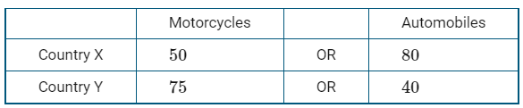
- The table above shows the quantity of motorcycles and automobiles produced by two countries that use the same amount of resources. Which of the following is true?
- Country X has an absolute and comparative advantage in the production of motorcycles.
- Country X has an absolute and comparative advantage in the production of both goods.
- Neither country has a comparative advantage in the production of motorcycles.
- Country Y has an absolute and comparative advantage in the production of automobiles.
- Country Y has an absolute and comparative advantage in the production of motorcycles.
- Which of the following is an example of how the consumer price index (CPI) exhibits bias in its estimates of changes in the cost of living?
- Energy prices have a higher impact on inflation than other input costs do.
- New products are always overrepresented in the CPI .
- The CPI assigns greater weight to measures of welfare than it does to economic activity.
- Product improvements are not always fully reflected in the calculation of the CPI .
- The CPI adjusts for the substitution of less expensive goods by consumers.
- Fred Jones withdraws $1,000 in cash from his savings account. What immediate effect does this transaction have on the monetary aggregate measures of M1 and M2 ?
M1 M2
- Increase Decrease
- Increase No change
- Decrease No change
- No change Decrease
- No change No change
- Whch of the following is true about inflationary expectations?
- The actual unemployment rate equals the natural rate of unemployment if the actual inflation rate exceeds the expected inflation rate.
- The actual unemployment rate equals the natural rate of unemployment when wages fully adjust to expected inflation.
- Expectations are always correct in the short run.
- The actual inflation rate is always equal to the expected inflation rate because of labor contracts.
- The natural rate of unemployment equals the inflation rate when the actual inflation rate equals the expected inflation rate.
- Which of the following transactions is included in the financial account of Country X’s balance of payments accounts?
- A firm in Country X sells robots to a firm in Country A.
- Country X sends financial aid to Country B.
- An individual in Country X receives dividend payments from a firm in Country C.
- An individual in Country X sends money monthly to family members in Country D.
- An individual in Country X buys new government bonds issued by Country E.
- Assume a country’s government increases taxes and its central bank decreases the money supply. The actions will result in an increase in which of the following in the short run?
- Aggregate demand
- Aggregate supply
- Investment spending
- Unemployment
- Inflation
- When there is excess demand in the loanable funds market, which of the following will occur?
- National savings will exceed investment spending.
- The economy will remain at full employment.
- Real interest rates will increase.
- An inflationary gap will exist.
- The money supply will increase.
- Which of the following is an assumption underlying an upward-sloping short-run aggregate supply curve?
- The economy is experiencing high inflation.
- The economy is at full employment.
- National income is fixed.
- Wages are sticky.
- The velocity of money is constant.
- The short-run Phillips curve implies there is a trade-off between
- rule making and discretionary policies
- monetary and fiscal policies
- inflation and unemployment
- budget deficits and interest rates
- interest rates and investment
- When Stephanie took out a one-year fixed-rate loan, she expected to pay a real interest rate of 3 percent. At the end of the year, the real interest rate had fallen to 2 percent. Which of the following could have caused the decrease in the real interest rate?
- There was an increase in the nominal interest rate.
- There was a decrease in the nominal interest rate.
- There was a decrease in the money supply.
- The actual inflation rate was greater than the expected inflation rate.
- The actual inflation rate was less than the expected inflation rate.
- A continuous increase in the consumer price index (CPI) is
- deflation
- stagflation
- inflation
- recession
- disinflation
- Which of the following would most likely lead to cost-push inflation in the short run?
- A decrease in labor productivity
- A decrease in income tax rates
- A decrease in consumers’ and businesses’ optimism about future economic activity
- An increase in government deficit spending to stimulate a weak economic recovery
- Discovery of new sources of energy
- The measured unemployment rate is often criticized for understating the level of joblessness because
- individuals working in the underground economy are counted as employed
- individuals working more than one job are counted more than once
- discouraged workers are counted as unemployed
- discouraged workers are not counted in the labor force
- part-time workers are counted as unemployed
- An economy is in short-run equilibrium at a level of output that is greater than potential output. If there were no active fiscal or monetary policy intervention, which of the following changes in output and the price level would occur in the long run?
Output Price Level
- Increase Decrease
- Increase Increase
- Decrease Decrease
- Decrease Increase
- No change No change

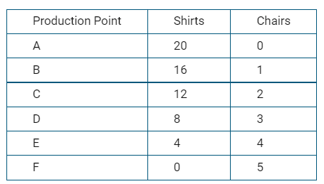
- The table shows the production possibilities for Country X in producing shirts and chairs when it uses all its available resources. The opportunity cost of producing one additional chair is
- zero
- constant
- increasing
- decreasing
- indeterminate
- An increase in which of the following will most likely cause an increase in aggregate demand and inflation in the short run?
- Income tax rates
- Input prices
- Government spending
- Real interest rates
- Savings
- If the central bank of a country wishes to maintain a stable nominal interest rate after a decrease in consumers’ spending, taking which of the following actions will achieve the goal?
- Increasing government spending
- Increasing income tax rates
- Decreasing the required reserve ratio
- Decreasing the discount rate
- Selling government bonds
- Investment in physical capital is most likely to occur as a result of an increase in
- interest rates
- inflation rates
- business confidence
- money demand
- personal consumption
- Country X’s government increases its spending without raising taxes. Which of the following is true about the effect on Country X’s real interest rates and its subsequent effect on Country X’s net exports?
- Real interest rates increase and net exports increase.
- Real interest rates increase and net exports decrease.
- Real interest rates increase with no change in net exports.
- Real interest rates decrease and net exports increase.
- Real interest rates decrease and net exports decrease.
- Which of the following shifts the money demand curve to the right?
- An increase in the price level
- A decrease in the price level
- An increase in interest rates
- A decrease in interest rates
- A decrease in the nominal gross domestic product
- An increase in the money supply will result in an increase in
- output in the short run and in the long run
- inflation in the short run and an increase in output in the long run
- inflation in the short run and no change in output in the long run
- output in the long run but not in the short run
- output in the long run and no change in inflation in the short run
- Which of the following is an example of frictional unemployment?
- A former mayor doing volunteer work
- A factory worker who loses her job because of recession
- A college student working part-time at the campus bookstore
- A college graduate interviewing for two available positions
- An architect whose job is replaced by computer software that designs buildings
- Assuming no government policies, which of the following will occur in the long run if the actual unemployment rate exceeds the natural rate of unemployment?
- Prices will increase.
- Unemployment will increase.
- Wages will fall.
- Aggregate demand will increase.
- Long-run aggregate supply will decrease.
- Assume that the market for bottled water is in equilibrium. If both the supply of and the demand for bottled water decrease, what will be the effect on equilibrium price and quantity?
Price Quantity
- Decrease Decrease
- Decrease Increase
- Increase Decrease
- Increase Indeterminate
- Indeterminate Decrease
- An increase in government spending that is financed by an equal increase in taxes results in which of the following changes in aggregate demand (AD) and short-run aggregate supply (SRAS) curves?
AD Curve SRAS Curve
- Shift right Shift right
- Shift left Shift left
- Shift right No change
- Shift left No change
- No change No change
- Assume that the United States current account balance is zero. If the United States dollar appreciates against the Japanese yen, then demand for United States exports will
- increase and result in a deficit in the United States financial account
- increase and result in a surplus in the United States financial account
- decrease and result in a surplus in the United States financial account
- decrease and result in a deficit in the United States financial account
- remain unchanged because the surplus in the current account will be offset by the deficit in the financial account
- If the government decreases spending while the country’s central bank buys bonds on the open market, wich of the following will definitely occur?
- The aggregate demand curve will shift to the right.
- The aggregate demand curve will shift to the left.
- The short-run aggregate supply curve will shift to the right.
- Interest rates will fall.
- Interest rates will rise.
- Which of the following best illustrates rising productivity?
- An expansion of the labor force
- An increase in the value of financial capital
- A decrease in the amount of physical capital per worker
- A decrease in the amount of labor needed to produce a unit of output
- An increase in the amount of resources required to produce a certain level of output
- Which of the following will most likely cause a depreciation in a country’s currency?
- An increase in the country’s price level
- An increase in the country’s real interest rate
- A decrease in the country’s expected inflation
- A decrease in the country’s real gross domestic product
- A decrease in the country’s money supply
- Banks create money when
- they make loans
- the loans they make are repaid
- they keep all excess reserves
- customers increase their cash withdrawals from their savings accounts
- the money multiplier is less than one
- Which of the following is true about a country’s national debt?
- It is the sum of the country’s trade deficit and government budget deficit.
- It increases when gross domestic product increases.
- It increases when the country’s government has a budget deficit.
- It decreases when the country’s exports exceed its imports.
- It decreases when national savings decrease

Free Response Section

Question 1
Include correctly labeled diagrams, if useful or required, in explaining your answers. A correctly labeled diagram must have all axes and curves clearly labeled and must show directional changes. If the question prompts you to "Calculate," you must show how you arrived at your final answer.
Assume that a country’s economy is currently in recession.
(a) Draw a correctly labeled graph of the long-run and short-run Phillips curves. Label the current equilibrium as point Z.
(b) Assume banks in the country hold no excess reserves and the public’s holding of currency is constant. The required reserve ratio is 25%. The central bank of the country buys $100 billion in bonds from the nonbank public.
(i) By how much will the monetary base of the country change?
(ii) Calculate the change in the amount of loans in the banking system in the country.
(iii) Calculate the change in the money supply in the country.

(c) Draw a correctly labeled graph of the money market and show the effect of the change in the money supply identified in part (b)(iii) on the nominal interest rate.
(d) Assume there is no change in inflationary expectations. On your graph in part (a), label a point W that is consistent with the effect of the change in the nominal interest rate identified in part (c).
(e) Based on the change in the interest rate identified in part (c), how will the international value of the country’s currency change?
(f) Based on your answer in part (e), will the country’s net exports increase, decrease, or stay the same? Explain.

Question 2
Include correctly labeled diagrams, if useful or required, in explaining your answers. A correctly labeled diagram must have all axes and curves clearly labeled and must show directional changes. If the question prompts you to "Calculate," you must show how you arrived at your final answer.
Suppose that the United States government implements a fiscal policy that increases the budget surplus.
(a) Draw a correctly labeled graph of the loanable funds market and show the effect of the increase in the budget surplus on the equilibrium real interest rate.
(b) The European Union is a major trading partner of the United States. Given your answer in part (a) about the real interest rate, will the United States dollar appreciate or depreciate against the euro? Explain.
(c) Suppose that the Federal Reserve, the central bank of the United States, decides to offset the change in the value of the dollar identified in part (b).
(i) Would the Federal Reserve buy or sell the euro?
(ii) Would the Federal Reserve buy or sell the dollar?
(d) Suppose that the Federal Reserve wants to counteract the real interest rate change identified in part (a). What open-market operation would the Federal Reserve use?

Question 3
Include correctly labeled diagrams, if useful or required, in explaining your answers. A correctly labeled diagram must have all axes and curves clearly labeled and must show directional changes. If the question prompts you to "Calculate," you must show how you arrived at your final answer.
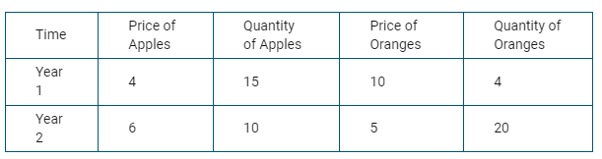
The table above shows data for the economy of Fruitland, which produces two goods, apples and oranges.
(a) Calculate the nominal gross domestic product ( GDP ) for year 2.
(b) Using year 1 as the base year, calculate real GDP for year 2.
(c) Calculate the GDP deflator for year 2.
(d) Assuming the market basket is composed of the quantities in year 1, calculate the consumer price index ( CPI ) for year 2.
(e) Suppose apple and orange pickers received a 2 percent increase in their wages. Based on your answer to part (d), would real wages of apple and orange pickers increase, decrease, or stay the same from year 1 to year 2 ? Explain.

Answers

Multiple Choice
1 | D | 11 | A | 21 | C | 31 | D | 41 | A | 51 | D
2 | C | 12 | E | 22 | D | 32 | B | 42 | D | 52 | C
3 | B | 13 | D | 23 | D | 33 | B | 43 | D | 53 | E
4 | C | 14 | D | 24 | A | 34 | E | 44 | B | 54 | C
5 | B | 15 | B | 25 | C | 35 | D | 45 | C | 55 | C
6 | A | 16 | E | 26 | D | 36 | C | 46 | E | 56 | D
7 | B | 17 | E | 27 | D | 37 | D | 47 | C | 57 | D
8 | C | 18 | D | 28 | B | 38 | C | 48 | B | 58 | A
9 | B | 19 | B | 29 | D | 39 | D | 49 | A | 59 | A
10 | C | 20 | B | 30 | E | 40 | C | 50 | C | 60 | C

Free Response

Question 1
a
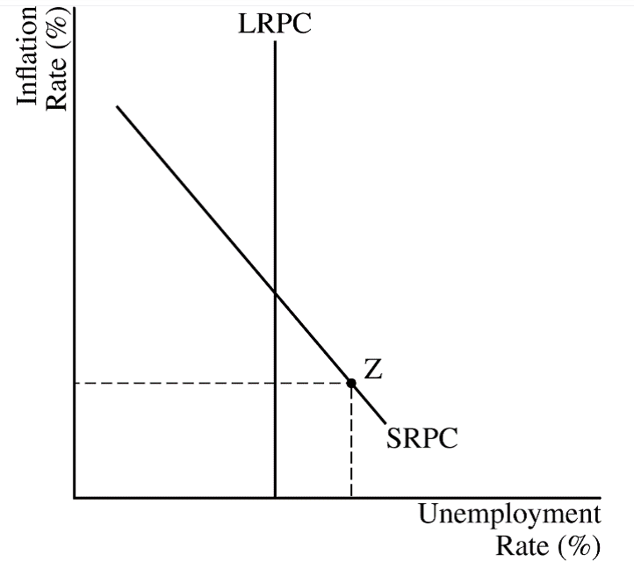
b
The response accurately includes all the criteria below.
State that the monetary base will change by $100 billion.
Correctly calculate the change in the amount of loans in the banking system as $300 (=4×$75).
Correctly calculate the change in the money supply as $400 (=4×$100).
C
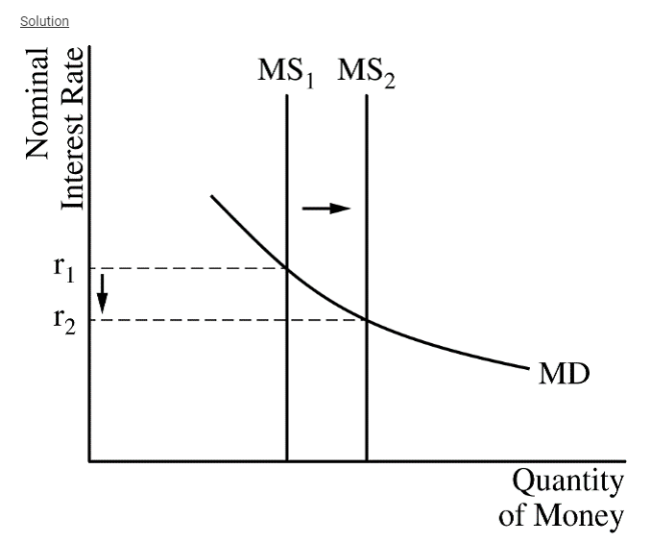
D
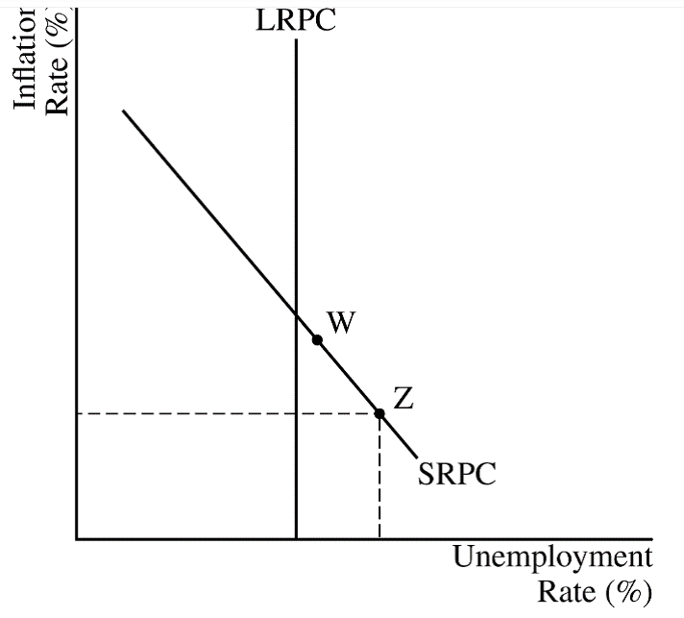
- The response states that the country’s currency will depreciate.
- The response states that net exports will increase and explains that this is because the country’s goods will be relatively cheaper than foreign goods.

Question 2
A
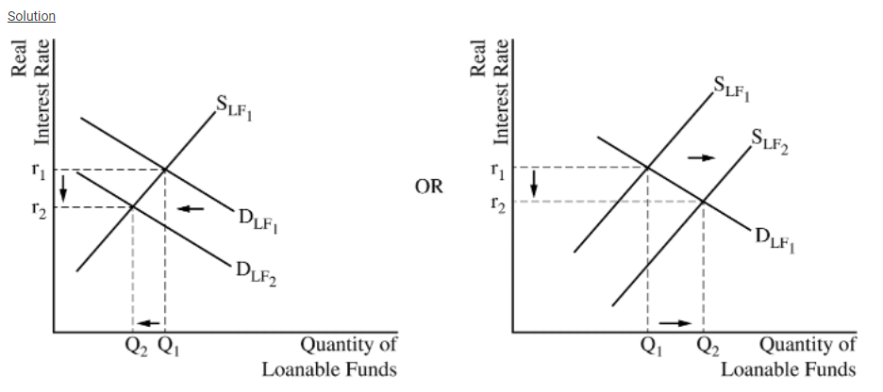
- The response states that the dollar will depreciate against the euro and explains that the demand for United States financial assets decreases which decreases the demand for the dollar or increases the supply of the dollar. (It is also acceptable to explain that as investors seek higher returns in foreign financial assets, there will be financial capital outflows, which decreases the demand for the dollar or increases the supply of the dollar.)
- The response states that the Federal Reserve should sell the euro and buy the dollar.
- The response states that the Federal Reserve should sell bonds.

Question 3
- Nominal GDP for year 2 – 6 x 10 + 5 x 20 = 160
- Real GDP for year 2 = 4 x 10 + 10 x 20 = 240
- GDP Deflator for year 2 = 160 / 240 x 100 = 67
- CPI for year 2 = 110/100 x 100 = 110
- Real wages will decrease and the increase in nominal wages is lower than inflation. 2% < 10%

